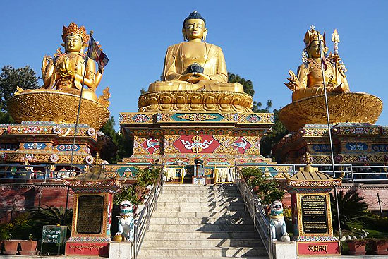
DISCOVER NEPAL - 14 days

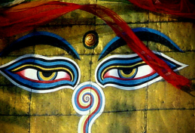
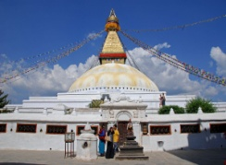
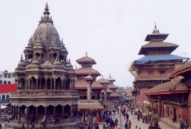
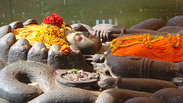
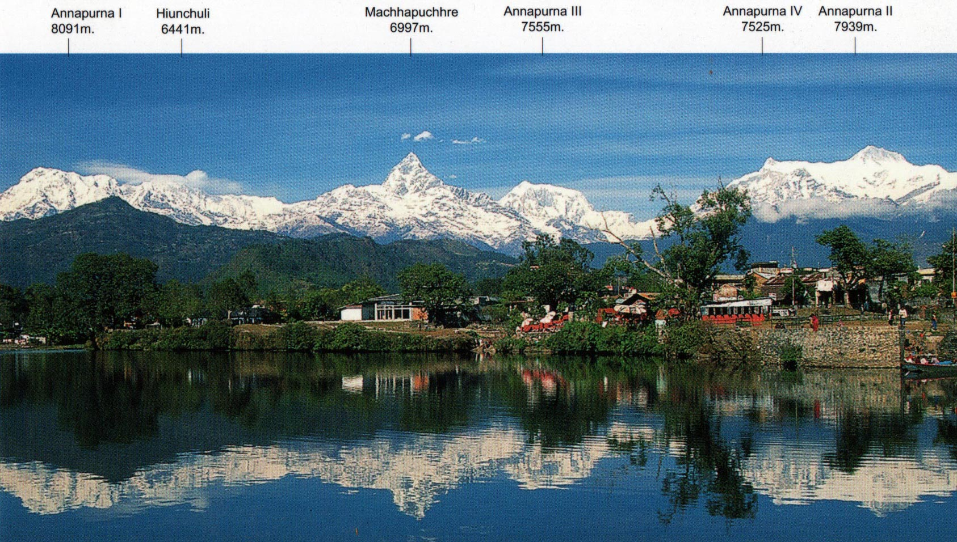
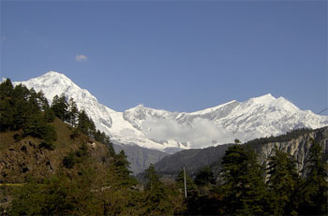
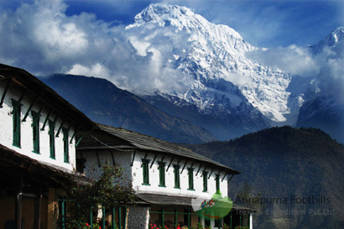
SKELETAL ITINERARY:

Day 01: Arrive Kathmandu
Day 02: Full day Sightseeing Tour
Day 03: Full day Sightseeing Tour
Day 04: Fly to Pokhara & drive to Phedi, trek to Dhampus [1700m]
Day 05: Trek to Landrung [1550m]
Day 06: Trek to Jhinu [1760m]
Day 07/08: Trek to Ghandruk [1940m]
Day 09: Trek to Nayapul, drive to Pokhara
Day 10: Indulge on your own activities.
Day 11: Drive to Chitwan.
Day 12: In Chitwan
Day 13: Fly back to Kathmandu.
Day 14: Final departure.

DETAILED ITINERARY:

Day 01: ARRIVE KATHMANDU

It is a panoramic thrill flying into Kathmandu on a clear day. The views of snow-capped mountain peaks sprawling down below you are almost ecstatic, beginning a whole chain of memorable experiences that stay with you for a long, long time. A representative and driver from Aroma Nepal Treks will meet you at the airport and escort you hotel. The representative will help you check into hotel. At the hotel you will be briefed about your daily activities.

Check In at the hotel. Overnight at Hotel.

Day 02: FULL DAY SIGHTSEEING TOUR B

After breakfast at the hotel, commence the sightseeing tour of Pashupatinath, Bouddhanath, Kathmandu city and Swayambhunath.

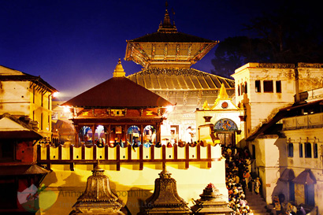
PASHUPATINATH: Pashupati Temple stands in the center of the town of Deopatan, in the middle of an open courtyard. It is a square, two-tiered pagoda temple built on a single-tier plinth, and it stands 23.6 meters above the ground. Richly ornamented gilt and silver-plated doors are on all sides.
On both sides of each door are niches of various sizes containing gold-painted images of guardian deities. Inside the temple itself is a narrow ambulatory around the sanctum. The sanctum contains a one-meter high linga with four faces (chaturmukha) representing Pashupati, as well as images of Vishnu, Surya, Devi and Ganesh.
The priests of Pashaputinath are called Bhattas and the chief priest is called Mool Bhatt or Raval. The chief priest is answerable only to the King of Nepal and reports to him on temple matters on a periodic basis.
The struts under the roofs, dating from the late 17th century, are decorated with wood carvings of members of Shiva's family such as Parvati, Ganesh, Kumar or the Yoginis, as well as Hanuman, Rama, Sita, Lakshman and other gods and goddesses from the Ramayana.
Pashaputi Temple's extensive grounds include many other old and important temples, shrines and statues. South of the temple, for instance, is Chadeshvar, an inscribed Licchavi linga from the 7th century, and north of the temple is a 9th-century temple of Brahma. On the south side of Pashupati temple is the Dharmashila, a stone where sacred oaths are taken, and pillars with statues of various Shah Kings.
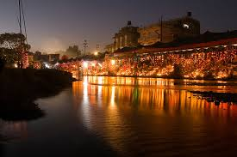
The Bagmati River, which runs next to Pashaputinath Temple, has highly sacred properties. Thus the banks are lined with many ghats (bathing spots) for use by pilgrims. Renovating or furnishing these sites has always been regarded as meritorious.
Arya Ghat, dating from the early 1900s, is of special importance because it is the only place where lustral water for Pashupatinath Temple can be obtained and it is where members of the royal family are cremated. The main cremation site is Bhasmeshvar Ghat, which is the most-used cremation site in the Kathmandu Valley. The preferred bathing spot for women is the Gauri Ghat, to the north.
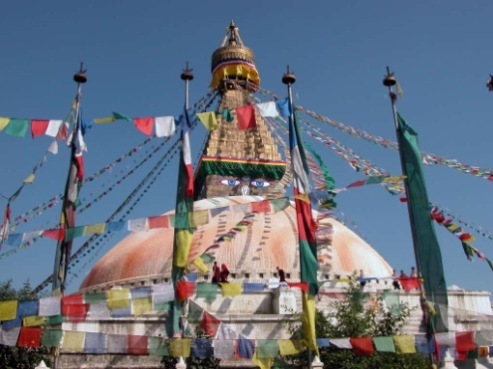
We carry on the sightseeing tour of the BOUDHANATH: the world’s largest stupa. It is a site of great reneration to the Buddhists. Bouddhanath is the center of Tibetan culture in Nepal. The 36-meter-high stupa of Bouddhanath is one of the largest stupas in South Asia. Bouddhanath Stupa was renovated by Licchavi rulers in the eighth century. The mandala design in Bouddhanath is a copy of the one in Gyangtse in Tibet. The stupa is located in the area of ancient trade route to Tibet where Tibetan merchants rested and offered prayers for many centuries. When refugees entered Nepal from Tibet in the 1950s, many decided to live around Bouddhanath. Hence, a complete township has developed around Bouddhanath. The stupa is said to entomb the remains of a Kasyap sage venerable both to Buddhists and Hindus. Smaller stupas are located at the base. Gompa monasteries, curio shops, and restaurants surround Bouddhanath.

After lunch commence the sightseeing tour of Kathmandu city and Swayambhunath.
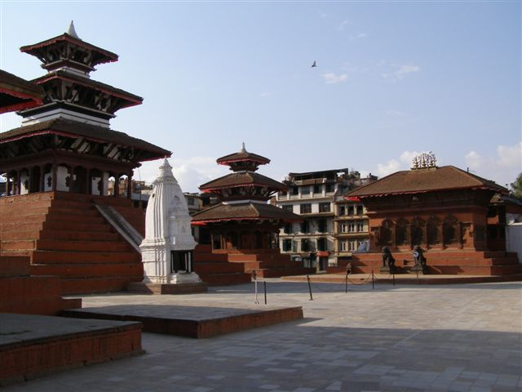
KATHMANDU CITY: Kasthamandap, the source of the name Kathmandu means ‘made from the timber of a single tree’. Also known as Kantipur, the capital Kathmandu is the hub of Nepal's art and culture. It is a place for rest, relaxation and easy-day sightseeing of historic and artistic temples and monuments. Kathmandu Durbar Square with its arrays of temples, Seto Machhindranath and the ancient palace of the former Nepali Royals enriches your experience of the centuries old civilisation.

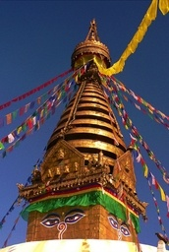
SWAYAMBHUNATH STUPA: Said to be around 2000 years old, this Buddhist Stupa sits atop a hill. The main stupa is composed of a solid hemisphere of brick and earth supporting a lofty conical spire crowned by a pinnacle of Copper gilt. Painted on the four sided base of the spire are the all seeing eyes of Lord Buddha. The hill of Swayambhunath is a mosaic of small Chaityas and Pagoda temples. You’ll get a scenic view of Kathmandu city from there.

Overnight at Hotel.
Day 03: FULL DAY SIGHTSEEING TOUR B

OPTIONAL: MOUNTAIN FLIGHT
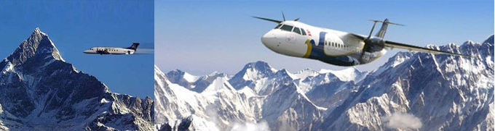
One of the must-see landmarks of Nepal is, of course, the highest peak in the world – Mount Everest. An awe-stricken silence comes close to matching the experience of a mountain flight. For one hour, you’ll fly over the Eastern Himalayan Ranges of Nepal where some of the highest peaks in the world including Mt. Everest lie for a surreal feeling as you come face to face with the world’s tallest and most enigmatic of Mountains.
Even those visitors who like the rigors of a trek won’t miss the opportunity to “conquer” the mountains in one stunning swoop.

After breakfast at the hotel, commence the sightseeing tour of Patan city, Buddhanilkhantha and Thamel.

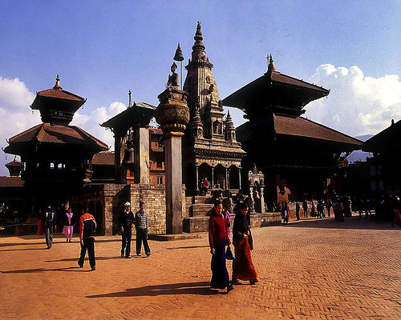
PATAN CITY: Located about 5 km south of Kathmandu, Patan is one of 3 royal cities in the valley. A destination for connoisseurs of fine arts, Patan is filled with wood and stone carvings, metal statues, ornate architecture, including dozens of Buddhist and Hindu temples, and over 1200 monuments.

Patan is believed to have been built in the third century B.C. by the Kirat dynasty later expanded and enriched by the Licchavi and the Malla rulers in the medieval period. Patan Durbar Square, like its counterpart in Kathmandu, is an enchanting mélange of palace buildings, artistic courtyards and graceful pagoda temples. The former Royal palace complex is the centre of Patan’s religious and social life, and houses a beautiful museum.

After lunch drive to Buddhanilkhantha and Thamel.

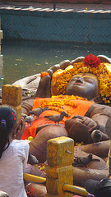
Eight kilometres north of Kathmandu is a remarkable, colossal statue of lord Vishnu reclining on a bed of snakes. The fifth-century statue lies in the middle of a small pond Budhanikantha is a place of pilgrimage for all Hindus and is the scene of great activity at such festivals as Haribodhini Ekadasi and Kartik Poornima. An interesting feature of this shrine is that the reigning King of Nepal may not visit the spot according to an old tradition.

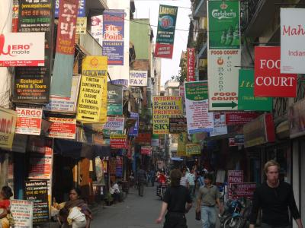
Thamel is the epi-center for shopping in Kathmandu. It can be a stressful place because of the street vendors, rickshaw drivers and high speed motorbikes. But there is no question that it is jam- packed with shops, selling everything from ready-to-wear Western clothes, embroider T-shirts, Tibetan carpets, clothing, Thangkas (Buddhist paintings) and curios (“singing bowls” etc), Pashmina shawls, Nepali souvenirs like khukuris (Gurkha’s traditional knife) and madals (drums), jewellery, paper products (the local lokta plant is used to make a fine & unique paper – a nice and practical souvenir or gift), colorful masks and puppets, metalwork & woodcarvings

Overnight at Hotel.
Day 04: FLY TO POKHARA & DRIVE TO PHEDI, TREK TO DHAMPUS [1680M] / POTHANA B,L,D
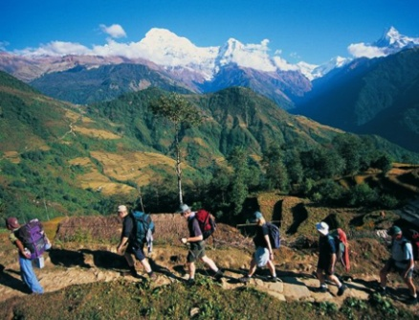
Your trip starts with your 45 minute flight from Kathmandu to Pokhara. During your flight, you will be sightseeing the most magnificent and sensational view of Himalayan range. As your flight lands on Pokhara, you will be mesmerized by the irresistible visual treat of Manaslu and the Annapurna mountain range. In Pokhara, You will drive from Pokhara to Phedi. From there onward begins your trekking in Annapurna mountain range. As you climb uphill, you will bask in the splendor of nature and your trails become more adventurous. Finally, after walking for 3 hours, you encounter several roadside teashops and at last your trail leads to the Gurung village of Dhampus. Here concludes your trip of the day.
Lunch, Dinner and overnight at Local Lodge.

Day 05: TREK TO LANDRUNG [1650M] B,L,D

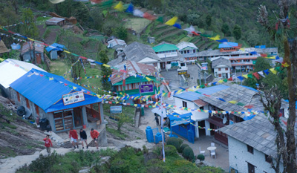
Your path narrows as it skirts round a ridge snout. On proceeding further, you pass through Pothana and reach Deorali. At this point, you find yourself high up on the East side of the Modi Khola cascading down the Annapurna Circuit Sanctuary surrounded by complete ambience of nature. Continue with your trekking for four hours until you reach picturesque Gurung settlement of Landrung. Spectacular views of Annapurna South and Hiunchuli instill more zest and excitement into your adventure spirit.

Breakfast, Lunch, Dinner and overnight at Local Tea house.

Day 06: TREK TO JHINU DANDA [1760M] B,L,D

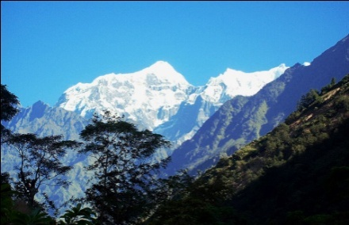
In the morning after having breakfast, we will descend to small stream and climb up with small stone staircase with zigzag uphill through the terrace fields viewing Jhinu Danda and Chhomrong village from top of the ridge, with its small settlement which takes about 2 and half hour. We can see a second largest Gurung village of Ghandruk high above us on the opposite side of the river. Then, we will leave the village and choose the right trail; walk on the thick jungle trail descends through ferns to fine view of Annapurna South high above the jade-white water river and cross the several bridges with lovely waterfall near the Himal Qu. Then, we will cross by a long narrow suspension bridge over the Modi Khola until reaching New Bridge which takes about 1 and half hour. We will make our lunch there. After lunch, we will continue to steep climbs and then cross over the stream. Then a short stiff climbs bring us to Jhinu Danda which takes about 1 to 2 hours. There is a hot spring with cement bathing pools about 25 minutes downhill.
Breakfast, Lunch, Dinner and overnight at Local Tea house.

Day 07: TREK TO GHANDRUK [1952M] B,L,D

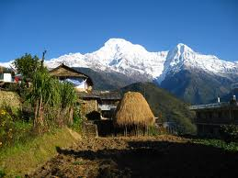
In the morning after having breakfast, we will descend to small stream and climb up with small stone staircase with zigzag uphill through the terrace fields viewing Jhinu Danda and Chhomrong village from top of the ridge, with its small settlement which takes about 2 and half hour. Then we walk small ups and downs through the dense forest of rhododendron viewing scenic Landruk and Ghandruk village until reaching Ghandruk, which is also known as Konda Village in their local language. Konda means Stone; we can see all the walking trail and house when we are entering in the village. It takes about 1 and half hour. We will have our lunch and visit a very interesting old traditional Gurung Museum and recently built Buddhist Monastery in the middle of the village, which we can make side trip for the evening.

Breakfast, Lunch, Dinner and overnight at Local Tea house.

Day 08: FREE DAY B,L,D

Visit the local village in Ghandruk. It sits at an altitude of 1940 meters above sea level and is inhabited of Gurungs, one of the many ethnic groups of Nepal, with their own religion and culture. The trekking offers the spectacular mountain scenery along with charming villagers.

Breakfast, Lunch, Dinner and overnight at Local Tea house.

Day 09: TREK TO NAYAPUL 1070M / DRIVE TO POKHARA B,L
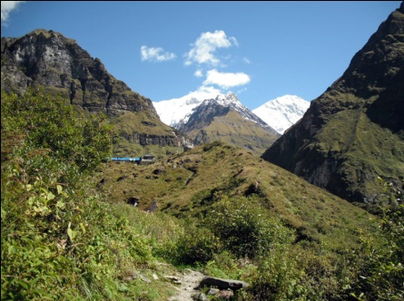
In the morning after breakfast, we will leave the village and walk down on the stone paved stone staircase for a while and viewing Landruk village just opposite side of us. After a 2 hours walk down from Ghandruk village, we arrive in Syaulibazar. Then, we will follow the plain dusty road way along the Modi Khola until reaching Birethanti which takes about 1 and half hour. We cross a river over an iron bridge and have our lunch there. After lunch, we continue 30 minutes further to Nayapul along the Modi Khola and our car will be there to pick up. Then, we back to Pokhara by car which takes about 2 hours and transfer to Hotel.

Overnight at Hotel.

Day 10: FREE DAY IN POKHARA B

Breakfast at Hotel.
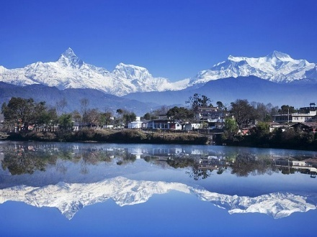
Pokhara is a remarkable place of natural beauty. At an elevation lower than that of Kathmandu, it has much more tropical feel to it; a fact well appreciated by the beautiful diverse flowers that prosper in this environment. The enchanting city with a population of around 95,000 has several beautiful lakes and offers stunning panaromic views of Himalayan peaks. The valleys surrounding Pokhara is home to thick forest, gushing rivers, emerald lakes and of course, the views of world famous Himalayas. The serenity of the lakes and the magnificence of the Himalayas rising behind them create an ambience of peace and magic.

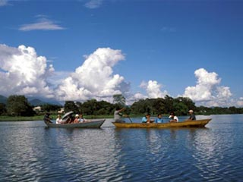
Optional boat ride at Lake Phewa.

Boat ride at Phewa Lake: Spend a quiet time boating in the ultimate lake where the reflections of Mount Annapurna and Macchapuchare range falls. You will also see a variety of fishes while boating. An island temple is located at the middle of the lake. Thick forest lies on the adjoining southern slopes of the lake. It’s hard to escape the draw of Phewa Lake and any visitor with even a few spare minutes should endeavour to take a boat out on the water to fully experience the wonderful views of the reflected mountains
Overnight at Hotel.
Day 11: DRIVE TO CHITWAN B,L,D

Breakfast at the hotel we drive to Chitwan which will take 4-5 hours under normal road condition.
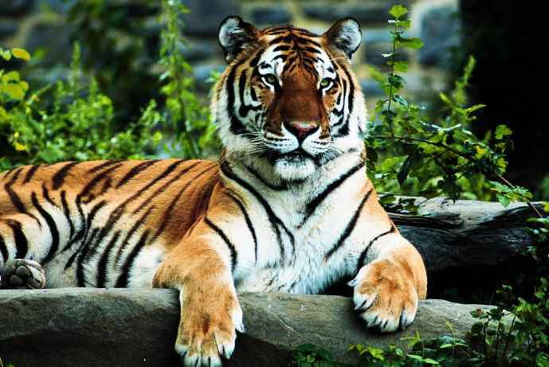
Chitwan National Park is a large and beautiful nature reserve occupying 932 sq. km. of land inhabitant of endangered royal Bengal tiger and the one-horned Indian rhino. Chitwan National Park was protected since the 19th century as a hunting reserve for Nepali royals and foreign aristocrats. In a famous hunting expedition, King George V and his son Edward VIII managed to slaughter 39 tigers and 18 rhinos in a single blood-soaked afternoon. Unfortunately, habitat loss and poachers continue to decimate the number of tigers and rhinos. Today, there are less than 80 tigers and 500 rhinos left in the Park. There are more than 50 species of mammals in Chitwan including monkeys, tigers, leopards, sloth bears, wild boar, hyenas, deer, elephants and rhinos. There are also 450 different species of birds and 67 species of butterflies. The main attraction of Chitwan is the Elephant Safari. It is a unique experience to explore the jungle on the back of a trained elephant. While you are not likely to see the Bengal tiger, you should be able to see the Indian rhino and enjoy one of the nicest nature reserves of the Indian sub-continent. Watch out for branches – particularly if you are sitting behind other passengers.
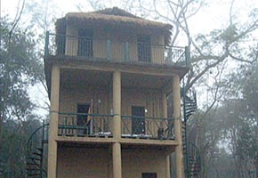
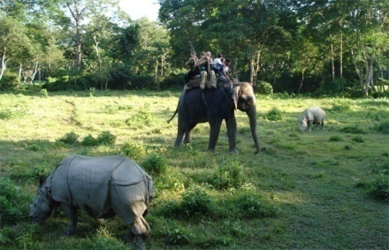
Elephant Safari and Visit to Observation Tower:
Seated high on the back of an elephant, gain a unique viewpoint of the Chitwan jungle. As an experienced mahout tracks animals through the dense jungle growth as you sit back on a howdah, you can imagine yourself being a Rajah or Rani going on a shooting trip (with cameras of course!) in the days of yore. An elephant safari allows you to go places that would be impossible to get to by foot or Jeep and get up close to the wild animals of the jungle that are normally wary, but at home with a fellow creature of the jungle
Spending some time on a nice observation tower in the jungle is another amazing experience. After an interesting jeep drive through different traditional villages to reach the tower.

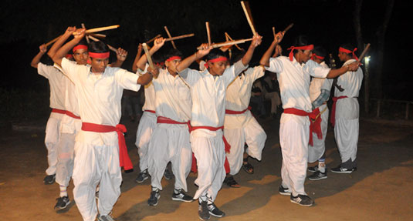
Tharu dance:
A melodious tribal dance performed by men and women with rhyme or drums and the clashing of sticks embodies and projects how to keep away the rhino and other wild animals from the human habitat and their farming land. You can enjoy your evening after dinner and watch the Tharu Stick Dance. We will arrange dance for your enjoyment adjacent to our Restaurant.
Lunch, Dinner and overnight at Hotel.

Day 12: JUNGLE ACTIVITIES B,L,D

Wake up call.
Morning tea/coffee
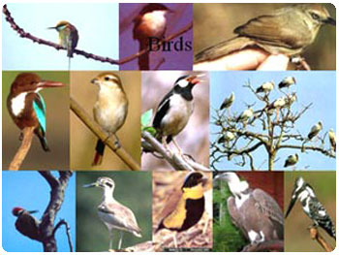
Bird watching
Chitwan is an ornithologist’s delight and a must for any serious twitchier, as more than 450 species of exotic birds such as the Oriental Pied Hornbill, Paradise Flycatcher, and Lesser Adjutant Stork congregate at this biological hotspot of Asia. Our experienced guides will take you to select spots ideal for birding, where you can observe a breathtaking diversity of these beautiful feathered creatures.
After having hearty breakfast at the resort commences the Dugout Canoe ride.

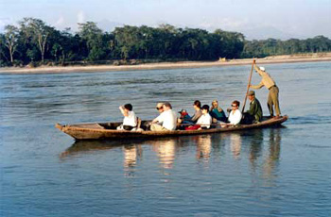
Dugout Canoe ride
Floating down to Rapti River by dugout canoe is the best way to discover the habitat of crocodiles on the bank of the river. It is also a relaxing and better way to watch the different kind of birds and wildlife species when they come to the bank of the river to drink water.

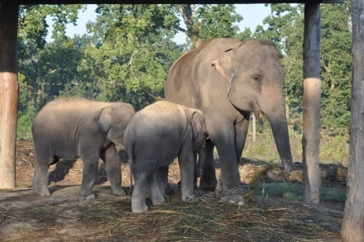
Elephant Breeding Center was established in 1985 at Royal Chitwan National Park (RCNP) and is the only EBC in Nepal. At the Elephant Breeding Program, 4km west of Sauraha, elephants are breed and trained. The best time to visit is in the afternoon when the elephants are fed. The Elephant Breeding Centre of Sauraha with great tourist attraction is said to be one of the only 3 such centers in the world.
Elephant skin is extremely sensitive to sunburn and insect bites; they roll in dust and mud and throw dust on their backs to help protect their skin. This was one of such moments when this restless young Elephant tried to get rid of insect.
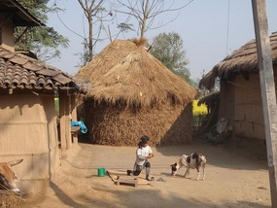
Tharu village visit
Tharu are indigenous people of the Terai. They have a distinct architectural style, building solely of the natural materials found in the area; straw, wood and mud. Even though by now almost all Tharus are Hindus some elements of their tribal religion can still be found. The villages are often peaceful, non-industrial havens, with the inhabitants engaged in a yearly agricultural circle.
Drive back to lodge.
Breakfast, Lunch, Dinner and overnight at Hotel.

Day 13: FLY BACK TO KATHMANDU B

After breakfast at the hotel transfer to Bharatpur airport and fly back to Kathmandu.

Free day in Kathmandu OR do last minute shopping in the local tourist market -Thamel.
Overnight at Hotel.

14 Day: DEPART KATHMANDU B

Breakfast at the hotel
We ensure that you will leave Kathmandu with cherishing memory and an experience of a lifetime. Our representative from Aroma Nepal Treks will drive you to the airport in time for your flight back home. Journey well!
*****HAVE A PLEASANT JOURNEY*****

The Package cost Includes  - Assisted upon arrival at the airport by our office representative.  - All arrival and departure transfers as per the itinerary by a/c vehicles.  - 03 nights twin/double room accommodation as per the above hotel in Kathmandu on Bed & Breakfast basis.  - 02 nights twin/double room accommodation as per the above hotel in Pokhara on Bed & Breakfast basis.  - 05 nights / 06 days Dhampus /Ghandruk trek using local lodges’ en-route on full board basis including guide, porters as per the group strength.  - Annapurna Conservation Area Project fees and Trekkers’ Information Managements System [TIMS].  - 02 nights-03 days twin/double room accommodation as per the above hotel in Chitwan on full board basis including all jungle activities and national park entrance fees.  - Airfare for the sector Kathmandu / Pokhara & Bharatpur / Kathmandu with airport transfers.  - All sightseeing tours mentioned above itinerary with our local English speaking guide in Kathmandu including entrance fee.  - Surface transfers Pokhara / Chitwan with necessary vehicle retention.  - All applicable taxes presently 24.3% | The Package cost Excludes  - International Airfare and taxes.  - Nepal visa fee.  - Sightseeing which is not mentioned in above itinerary.  - Personal expenses.  - Any transportation cost outside of the regular itinerary.  - Any insurance.  - Expenses of personal nature.

General Information & Travel Tip
Passport and Nepal visa information
Nepal travel tips
All foreign tourists travelling to Nepal will need a valid passport and a Nepali tourist visa. Your passport should have at least 6 months validity left on it, beyond your expected departure date. You can obtain a Nepali tourist visa from the local embassy or consulate or on arrival at Kathmandu's Tribhuvan airport (or other major arrival points in Nepal). To enter Nepal you'll need a valid passport, 2 passport size photos and a completed visa application form. A Nepal visa is usually valid for 3-6 months.
Nepal travel tips – Costs

Cash Machines
The mainstream banks in Kathmandu and Pokhara all have a cash machine where you can fill your wallet 24 hours a day using your normal bankcard or Master card / Visa. Smaller banks such as the Himalaya Bank also have cash machines, though we would recommend only using these machines during bank opening hours so as not to run the risk of losing your card if the system crashes(on rare occasions).

Credit Cards
Major credit cards are generally accepted in Kathmandu and Pokhara. Standard Chartered Bank and several smaller banks such as Nabil Bank and the Himalaya Bank will give an advance in rupees on your Master card or Visa. It's wise to carry some US dollars and rupees in small denomination notes in the smaller towns where you can't use your credit card.

Nepal Travel Health
Nepal Travel Plan has taken the greatest care to ensure that the contents of these pages are accurate. We
advise customers to contact their local GP regarding their health in Nepal for the latest information at least 6 weeks prior to departure.
Nepal is a (sub) tropical country and you therefore run greater risk of becoming ill than at home. There are more varieties of bacteria in a tropical climate, and your body isn't as used to them (as you don't live in that area of the world). Although the risk of getting ill must not be exaggerated, and certainly should not spoil your enjoyment of the holiday, it is advisable to be prepared for your trip and to be aware of the health risks of that country.

If you are currently taking prescription medicines, be sure to pack enough spare medicines and carry the instruction leaflet with you. This will make life a lot easier if you happen to lose the medicine, especially when trying to explain the medication to a Nepali pharmacist. Although the marketing name may vary from country to country, the chemist will certainly understand the written chemical contents.
If you wear glasses or contact lenses, be sure to take a copy of your prescription, as well as extra glasses or spare lenses.
Contact your local GP or tropical medical centre before you leave. Last minute trips to Nepal shouldn't be a problem to an already healthy person, but be sure to double check for an up-to-date advice before you leave. Always carry your vaccinations’ booklet with you.
Here is a summary of information aimed at healthy, non-pregnant travelers planning to stay in Nepal for up to one month or less:
Malaria
Malaria exists in Nepal and India, however the risk varies greatly across different regions. Whether you will need anti-malaria tablets depends upon your travel plans. The type of anti-malaria medication that you take depends on the strain that is prevalent in your destination.
The best bet is to try and reduce the risk of catching malaria by preventative measures. Keep your arms, legs and feet covered in the evenings, using anti-mosquito spray/cream on exposed areas of skin (the best ones contain DEET), and sleep under a mosquito net whenever possible. This is especially true in accommodation with no air-conditioning. It is possible to buy a mosquito net that is pre-impregnated with an insecticide.
If during or after your trip you find yourself with flu-like symptoms lasting longer than two days (even up to 2 months after your return to your country), seek advice of a doctor immediately, and advise you have been in a malaria area.
Vaccinations
Vaccinations against DTP (diphtheria, tetanus and polio; valid for about 10 years) and hepatitis A are advised. Most people had a DTP vaccination as a child and you can probably safely travel with a booster in this case. The normal injection with hepatitis A anti-body has a limited period of effectiveness so it makes good sense to have
this vaccination just before travelling. If you travel frequently to a country where hepatitis A is present, or plan to stay longer in tropical countries, you should opt for a vaccination with a longer effective period. Keep in mind that long-term vaccinations are more expensive and still require a booster after six months. Vaccination against enteric fever is advised if you plan to stay in Nepal longer than three months. Vaccination against yellow fever is only advised if you have been in an infected area prior to travelling to Nepal.

Dengue fever and Japanese B-encephalitis
Both of these diseases are carried by mosquitoes, so you can take preventative measures similar to malaria. Some species, like the Asian tiger mosquito, are known to fly and feed during daytime and under artificial light. For more information about these diseases, and the status of any epidemics, you're advised to seek the advice of the NHS or suitable medical institution.
There is no vaccine against dengue fever, however there is for Japanese B encephalitis, which is advised if you are going to be in Asia for longer than six months.
You can assemble your own tropical first aid kit or buy a ready-made kit. We advise you to obtain a book on how to stay healthy in the tropics, which will contain information about contents of a first aid kit.
Health on location
Besides the general advice given here ensure that you have the correct vaccinations before travelling in Nepal and remain as healthy as possible before you leave. Of course it's important that you avoid becoming ill while you're travelling but remain alert of any symptoms of illness: when in doubt, consult a doctor.
Jet lag
Jet lag occurs when your biological clock is confused (primarily your sleeping and waking rhythms) by flying through time zones. The body has to adjust to the new biorhythm for the first few days after your flight during which time you can feel tired and irritable.
We advise that during the flight you drink very limited amounts of coffee or alcohol and upon arrival don’t demand too much of your body for the first couple of days. It's also handy to get into the new sleeping rhythm as quickly as possible. We recommend an hour of sleep after arrival, and then remain awake until you take an early night.

Diarrhea
A change of rhythm, climate and food (especially spicy) can throw your stomach out of sorts. If you start feeling dodgy, just take it easy and drink plenty of water in small quantities. It may be necessary to take some Oral Rehydration Salts (ORS) dissolved in water to prevent dehydration and this is especially important for the elderly and children. Drugs such as loperamide and diphenoxylate, may be taken if you really have to travel when you have diarrhea (not suitable for children under two years old). These drugs have the effect of sedating the intestine, which stops stomach cramps and suppresses the feeling of diarrhea. Only use these drugs when you're on the move and cannot get to the toilet regularly. If the diarrhea persists for more than 48 hours, AND is accompanied by headache, vomiting, or blood in the stool OR you’re taking any other medication at the time, you should contact a doctor. The doctor can send a sample for lab analysis to determine exactly what’s going on. Your diarrhea can stop quite quickly, but can leave a lasting feeling of lethargy due to the fact that your intestines needs time to recover.

Preventing diarrhea
Only consume water and soft drinks from properly closed and sealed tins or bottles, or drink boiled water (tea or coffee). Ice is safe if it's in the form of machine-produced ice cubes. Fruit juice is safe, provided no water has been added.

Food, particularly meat and fish, must be well cooked. In general, we advise against the western-style salads offered in salad bars (in inexpensive hotels and restaurants). Generally, it is safe to eat from street stalls, even though you would expect the opposite. Eat where it's busy, as the time between food preparation and consumption is the shortest and this is good for hygiene. Take note of how the plates, glasses and cutleries are washed because often, there is no running water and only a bucket with soap in it, baking in the sun. If that's the case, be sensible and find somewhere else to eat.
Many restaurants have open plan kitchens, so anywhere that looks clean is probably a safe bet. With regards to street stalls, it’s probably wise not to eat meat at the end of the day - the meat could have been lying around, sometimes all day, unrefrigerated. A tried and trusted housewives remedy to prevent dehydration during diarrhea is to drink cola and stock (not at the same time obviously). Cola can be bought everywhere and you can bring stock cubes and a single-cup beverage with you.

Additional HEALTH tips for travelling in Nepal travel
Skin care
Take all cuts, scratches etc in the tropics seriously: keep a close eye on them, clean them with disinfectant and keep them covered with a plaster during the day. Don't scratch mosquito bites.
Always use a high factor sunscreen cream on exposed skin, even in the rainy season. The sun is super strong particularly at high altitudes, even if it's cloudy.
You can avoid attracting biting insects by not wearing brightly coloured or black clothing, strong perfume or deodorant or aftershave. If you’re prone to skin irritations, wear cotton or linen clothing. You can help avoid prickly heat by using talcum powder on your body after your morning shower.
Wash or disinfect your hands after using the toilet and don't bite your nails.
During the dry season, in the wooded areas, there’s a slight chance that a tick may land on you. Check your body for these bugs in the morning and evening; especially behind the knees and in the genital area. Should you find one, don't try to just pull it out but use tick pincers (obtainable from chemists) or seek medical attention. If, after being in the woods, you find a bloody circular skin wound slowly increasing in size, seek professional medical attention.

Sunstroke
Sunstroke can be prevented by drinking water, wearing a hat and sunglasses. Always keep a bottle of water with you, especially if you're off the beaten track and unlikely to come across drinking water. If you suspect sunstroke (feeling light-headed, headaches), you can prevent it from getting worse by drinking water and if possible find somewhere in the shade to sit and stay there until you feel well enough.
Health upon return
If upon your return (and this can occur months later), you experience influenza, stomach problems, or experience some other unusual symptoms, contact your GP and let them know where and when you were last in Nepal and what you did there.

