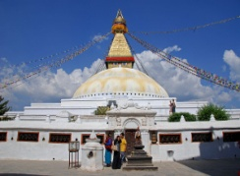
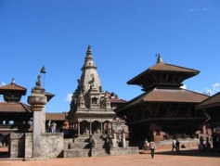
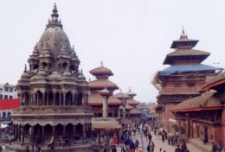
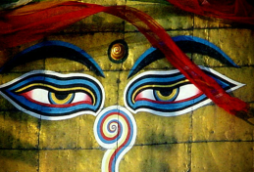
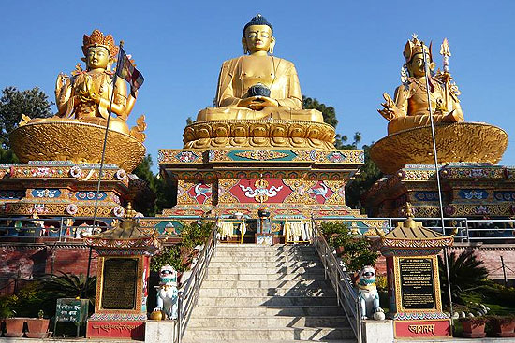
Foothill of Annapurna - 12 days
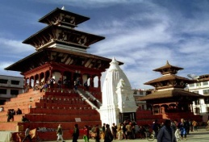
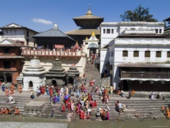
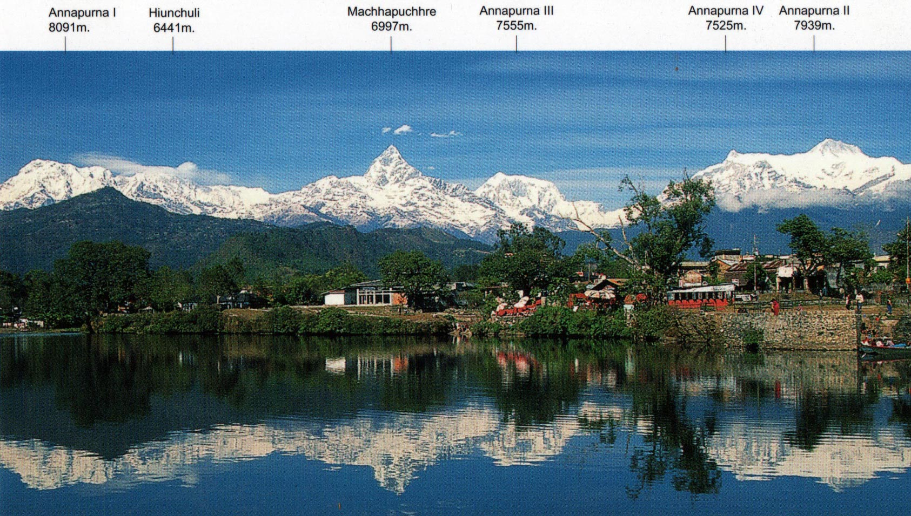

SKELETAL ITINERARY:

Day 01: Arrive Kathmandu.
Day 02: Sightseeing tour.
Day 03: Fly to Pokhara & Pokhara Sightseeing
Day 04: Trek to Ulleri.
Day 05: Trek to Ghorepani.
Day 06: Trek to Tadapani.
Day 07: Trek to Jhinu Danda.
Day 08: Trek to Pothana.
Day 09: Trek to Phedi / Drive to Pokhara.
Day 10: Free Day at Pokhara.
Day 11: Fly to Kathmandu.
Day 12: Fly back to Home / next destination.

DETAILED ITINERARY:

Day 01: ARRIVE KATHMANDU

It is a panoramic thrill flying into Kathmandu on a clear day. The views of snow-capped mountain peaks sprawling down below you are almost ecstatic, beginning a whole chain of memorable experiences that stay with you for a long, long time. A representative and driver from Aroma Nepal Treks will meet you at the airport and escort you to Hotel. The representative will help you check into hotel. At the hotel you will be briefed about your daily activities.

Overnight at Hotel.

Day 02: SIGHTSEEING TOUR B

After breakfast at the hotel commence the sightseeing tour of Kathmandu city, Swayambhunath and Patan city.
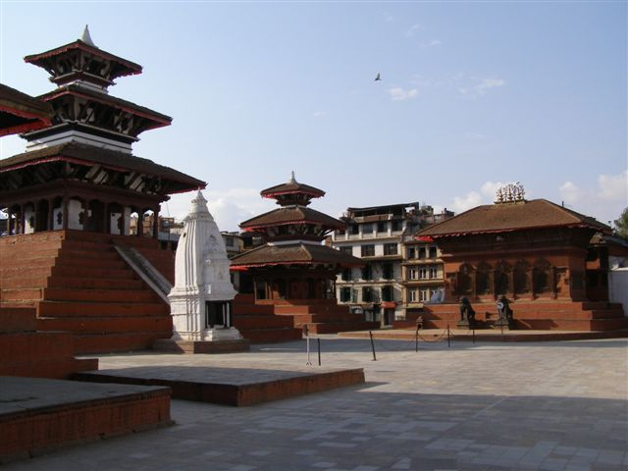
KATHMANDU CITY: Kasthamandap, the source of the name Kathmandu means ‘made from the timber of a single tree’. Also known as Kantipur, the capital Kathmandu is the hub of Nepal's art and culture. It is a place for rest, relaxation and easy-day sightseeing of historic and artistic temples and monuments. Kathmandu Durbar Square with its arrays of temples, Seto Machhindranath and the ancient palace of the former Nepali Royals enriches your experience of the centuries old civilisation.
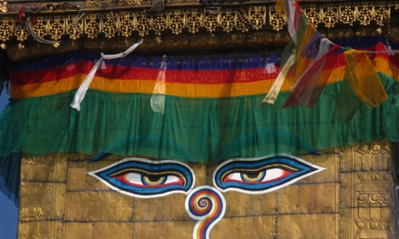
SWAYAMBHUNATH STUPA: Said to be around 2000 years old, this Buddhist Stupa sits atop a hill. The main stupa is composed of a solid hemisphere of brick and earth supporting a lofty conical spire crowned by a pinnacle of Copper gilt. Painted on the four sided base of the spire are the all seeing eyes of Lord Buddha. The hill of Swayambhunath is a mosaic of small Chaityas and Pagoda temples. You’ll get a scenic view of Kathmandu city from there.

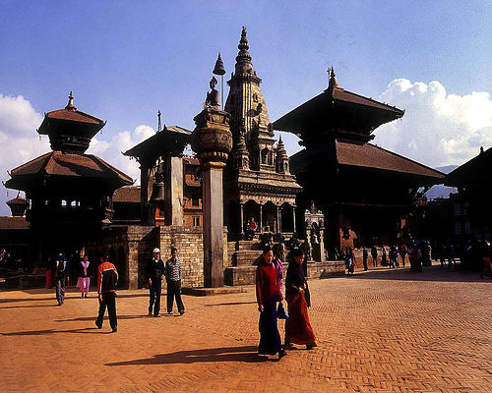
PATAN CITY: Located about 5 km south of Kathmandu, Patan is one of 3 royal cities in the valley. A destination for connoisseurs of fine arts, Patan is filled with wood and stone carvings, metal statues, ornate architecture, including dozens of Buddhist and Hindu temples, and over 1200 monuments.

Patan is believed to have been built in the third century B.C. by the Kirat dynasty later expanded and enriched by the Licchavi and the Malla rulers in the medieval period. Patan Durbar Square, like its counterpart in Kathmandu, is an enchanting mélange of palace buildings, artistic courtyards and graceful pagoda temples. The former Royal palace complex is the centre of Patan’s religious and social life, and houses a beautiful museum.

Overnight at Hotel

Day 03: FLY TO POKHARA & POKHARA VALLEY SIGHTSEEING B
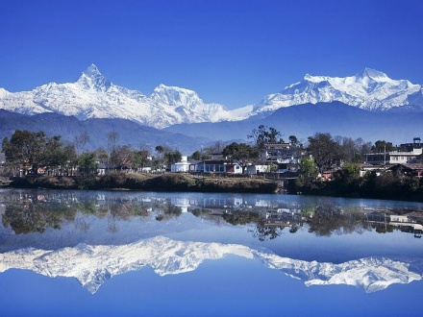
After breakfast at the hotel drive to Kathmandu Airport and Fly to Pokhara (25 minute fliight.), arrival in Pokhara and transfer to Hotel. Pokhara is a remarkable place of natural beauty. At an elevation lower than that of Kathmandu, it has much more tropical feel to it; a fact well appreciated by the beautiful diverse flowers that prosper in this environment. The enchanting city with a population of around 300,000 has several beautiful lakes and offers stunning panaromic views of Himalayan peaks. The valleys surrounding Pokhara is home to thick forest, gushing rivers, emerald lakes and of course, the views of world famous Himalayas. The serenity of the lakes and the magnificence of the Himalayas rising behind them create an ambience of peace and magic.

Pokhara is the most popular destination for visitors to Nepal. The city is also known as the center of adventure. There is little in its past by way of neither history nor culture impact and the only important role that the old Pokhara played was that it was along the route of trade between India and Tibet. Today it is one of the fastest developing cities of Nepal, mainly due to tourism.
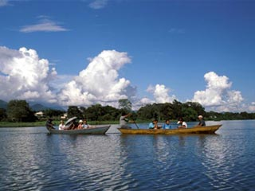
The natural beauty of its lakeside location and its proximity to the mountains has made it the natural choice for trekkers and adventures. Pokhara is also the base for some of most famous trekking circuits of Nepal. By itself surrounding area provides ample scope for short walk and day trips, suitable for children or weary trekkers, which can be made around the valley.
Afternoon start your Pokhara city tour including Devi’s Fall, Cave, Temple, Fewa lake where you can do boating. Some free time at Lakeside, main tourist area of Pokhara and back to Hotel.
Overnight at Hotel in Pokhara.

Day 04: POKHARA – NAYAPOOL – ULLERI (2073M.) B,L,D
Breakfast with a view of a wonderful mountain panorama before we set out for trekking in Annapurna.
This is a medium class trekking in the foothills of the Annapurna Range, which offers fantastic views of these mountains and glimpses of traditional village life. Most of the trekking variations will visit Ghorepani and Ghandruk. Ghorepani is the settlement (below Poonhill) of Magar people and Ghandruk was the first village to cater to tourists in Nepal. Poonhill (3,210 m.) is the best spot for mountain viewing and has the most magnificent view of the sunrise over the mountains you have ever seen! From Poonhill you can view more than 14 mountain peaks! The view takes in Dhaulagiri, the Annapurna and the distant Manaslu range. The Poonhill treks starts and ends in Nayapul, an hour and a half drive from Pokhara
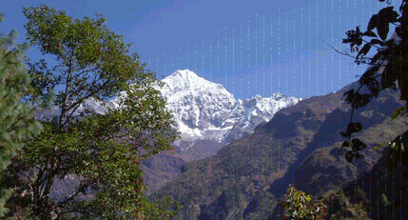
Drive from Pokhara to Nayapool for 42 km then trek start from Nayapool (1050m.0 to Birethanti for 25 min trek then you will cross Modi River. From here take left side, follow all the way to Burundi Khola to Ramghai/Hille for 2 Hrs where you will have lunch and after lunch from Ramghai about 1and half hrs and from hille about 30 min to Tirkhedhunga ( 1577m.) a small gurung village and from here cross the hanging bridge and trek one and half hrs trek up to Ulleri (2073m.). Ulleri is a small gurung village from where you will see the mounatin of Annapurna South (7219m.) and Himchhuli (6441m.).

Total walking Duration: 5-6 hrs. Distance: 13.Km
Dinner and Overnight at Trekking Guest House

Day 05: ULLERI - GHOREPANI B,L,D

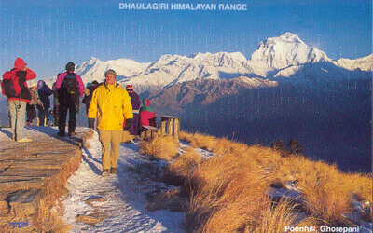
From Ulleri village after breakfast trek start to Banthanti for 45min( Village before start to forest-2350m.)and from Banthanti another one and half hrs gentle trek for NAngethanti (2550m.-Lunch place). Here you will walk inside of Oak and rhododendron forest. After lunch another one hours and 20 min for Ghorepani (2874m.) A beautiful Magar village from where you will see the range of Dhaulagiri and Annapurna ranges.

Total walking Duration: 4 hrs. Distance: 8 Km

Dinner and Overnight at Trekking Guest House

Day 06: GHOREPANI – TADAPANI B,L,D

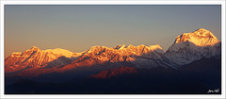
Early in the mroning before breakfast we have to start our sunrise trip from Poonhill (3210m. and 45min walk). Poonhill is a popular view point in Annapurna Ranges from where we can see the Maountain as: Dhaulagiri I-8167m., Tukuche Peak-6920m., Dhampus Peak-6012m., Nilgiri-7061m., Annapurna I-8091m., Annapurna South-7219m., Himchhuli-6441m., Fishtail-6997m., Annapurna II-7937m., Lumjung Himal-6920m., Manaslu-8163m., and many more.. After sunrise trip we will back to Ghorepani, Take breakfast and after breakfast we start our trek to Deurali for one and half hours up and gentle walk from the ridge. After deurali another one and half-hour gentle downhill to Banthanti for Lunch. After lunch one and half hours very nice gentle up and down to Tadapani Village (2660m.). Tadapani is a small gurung village totally surrounding by rhododendron forest from where you will get mountain view of: Annapurna South-7219m., Himchhuli-6441m., Fishtail-6997m., Mardi Himal etc in closed distance.

Total walking Duration: 5 hrs. Distance: 12 Km
Dinner and Overnight at Trekking Guest House

Day 07: TADAPANI – JHINUDANDA, Natural Hot Spring B,L,D

After breakfast at the hotel we start trek to Chhomrong first with down - hill and flat walk. Lunch at Chhomrong and after lunch trek down to JhinuDanda. Check in your hotel. Now you can go to natural Hotspring which is about 20-25 minite walk from your hotel just side of Modi river. Take your a pair of change cloth, water bottle and Towel with you. Spend you time there as you want or before sunset, back to Hotel, dinner and over night stay.
Total walking duration: - 5-6 hrs.
Dinner and Overnight at Trekking Guest House

Day 08: JHINUDANDA – POTHANA B,L,D

After Breakfast at Jhinu Danda gentle trek to Landruk-Tolka-Bichowk where you can have your lunch after four hours trek from Jhinu Danda and after lunch two hours up and gentle trek to Pothana and overnight stay there.
Total walking duration: -5-6 hrs.
Dinner and Overnight at Trekking Guest House

Day 09: POTHANA – PHEDI – POKHARA. B

This will be your last day for this trekking, start after breakfast, first one hrs gentle trek to (A beautiful Gurung Village in Nepal) and after Dhampus two hours trek down to Phedi and after lunch 30 minutes drive back to Pokhara.
Total walking duration : - 3 hrs.
Overnight at Hotel in Pokhara.

Day 10: POKHARA FREE DAY B

Breakfast at Hotel.
This is free day for you in Pokhara.
Some optional activities you can do on this day like
- Paragliding
- Ultra light Flight
- Bungee Jump
- Zip Line
- Mountain biking

Overnight at Hotel in Pokhara.

11 Day: POKHARA – FLY TO - KATHMANDU B

Breakfast at the hotel
Drive to Pokhara Airport and fly to Kathmandu. Arrival in Kathmandu and transfer to Hotel. Free day.

Overnight at Hotel in Kathmandu.

12 Day: DEPART KATHMANDU B

Breakfast at the hotel. We will drop you airport as per your international flight time

We ensure that you will leave Kathmandu with cherishing memory and an experience of a lifetime. Our representative from Aroma Nepal Treks will drive you to the airport in time for your flight back home. Journey well!
*****HAVE A PLEASANT JOURNEY*****

The Package cost Includes  - Assisted upon arrival at the airport by our office representative.  - All arrival and departure transfers as per the itinerary by a/c vehicles.  - 02 nights twin/double room accommodation at Soaltee Crowne Plaza or Hotel Shangri-La in Kathmandu on full board basis.  - 02 nights twin/double room accommodation at Mirable Resort in Dhulikhel on full board basis.  - 02 nights twin/double room accommodation at Gaun Ghar in Bandipur on full board basis.  - 2 nights twin/double room accommodation at Hotel Pokhara Grande [previous known as Hotel Blue Bird] in Pokhara on full board basis.  - 02 nights twin/double room accommodation at Godavari Village Resort in Godavari on full board basis.  - All sightseeing tours and transfers mentioned above itinerary with our local German speaking guide in Kathmandu and local English speaking guide in Pokhara including entrance fee.  - Surface transfers Kathmandu / Dhulikhel / Bandipur / Pokhara and Kathmandu / Godavari / Kathmandu with necessary vehicle retention.  - Manakamana Cable car ticket.  - Sarangkot sun rise view with our local English speaking guide.  - Boat ride at Lake Phewa/  - Airfare for the sector Pokhara / Kathmandu with airport transfers.  - All applicable taxes presently 24.3% | The Package cost Excludes  - International Airfare and taxes.  - Nepal Visa fee.  - Sightseeing which is not mentioned in above itinerary.  - Personal expenses.  - Any transportation cost outside of the regular itinerary.  - Any insurance.  - Expenses of personal nature.
Note:
We have included all meals during sightseeing tours and en-route at good restaurant and packed lunch from Hotel.
General Information & Travel Tip
Passport and Nepal visa information
Nepal travel tips
All foreign tourists travelling to Nepal will need a valid passport and a Nepali tourist visa. Your passport should have at least 6 months validity left on it, beyond your expected departure date. You can obtain a Nepali tourist visa from the local embassy or consulate or on arrival at Kathmandu's Tribhuvan airport (or other major arrival points in Nepal). To enter Nepal you'll need a valid passport, 2 passport size photos and a completed visa application form. A Nepal visa is usually valid for 3-6 months.
Nepal travel tips – Costs
Cash Machines
The mainstream banks in Kathmandu and Pokhara all have a cash machine where you can fill your wallet 24 hours a day using your normal bankcard or Master card / Visa. Smaller banks such as the Himalaya Bank also have cash machines, though we would recommend only using these machines during bank opening hours so as not to run the risk of losing your card if the system crashes(on rare occasions).

Credit Cards
Major credit cards are generally accepted in Kathmandu and Pokhara. Standard Chartered Bank and several smaller banks such as Nabil Bank and the Himalaya Bank will give an advance in rupees on your Master card or Visa. It's wise to carry some US dollars and rupees in small denomination notes in the smaller towns where you can't use your credit card.

Nepal Travel Health
Nepal Travel Plan has taken the greatest care to ensure that the contents of these pages are accurate. We
advise customers to contact their local GP regarding their health in Nepal for the latest information at least 6 weeks prior to departure.
Nepal is a (sub) tropical country and you therefore run greater risk of becoming ill than at home. There are more varieties of bacteria in a tropical climate, and your body isn't as used to them (as you don't live in that area of the world). Although the risk of getting ill must not be exaggerated, and certainly should not spoil your enjoyment of the holiday, it is advisable to be prepared for your trip and to be aware of the health risks of that country.

If you are currently taking prescription medicines, be sure to pack enough spare medicines and carry the instruction leaflet with you. This will make life a lot easier if you happen to lose the medicine, especially when trying to explain the medication to a Nepali pharmacist. Although the marketing name may vary from country to country, the chemist will certainly understand the written chemical contents.
If you wear glasses or contact lenses, be sure to take a copy of your prescription, as well as extra glasses or spare lenses.
Contact your local GP or tropical medical centre before you leave. Last minute trips to Nepal shouldn't be a problem to an already healthy person, but be sure to double check for an up-to-date advice before you leave. Always carry your vaccinations’ booklet with you.
Here is a summary of information aimed at healthy, non-pregnant travelers planning to stay in Nepal for up to one month or less:
Malaria
Malaria exists in Nepal and India, however the risk varies greatly across different regions. Whether you will need anti-malaria tablets depends upon your travel plans. The type of anti-malaria medication that you take depends on the strain that is prevalent in your destination.
The best bet is to try and reduce the risk of catching malaria by preventative measures. Keep your arms, legs and feet covered in the evenings, using anti-mosquito spray/cream on exposed areas of skin (the best ones contain DEET), and sleep under a mosquito net whenever possible. This is especially true in accommodation with no air-conditioning. It is possible to buy a mosquito net that is pre-impregnated with an insecticide.
If during or after your trip you find yourself with flu-like symptoms lasting longer than two days (even up to 2 months after your return to your country), seek advice of a doctor immediately, and advise you have been in a malaria area.
Vaccinations
Vaccinations against DTP (diphtheria, tetanus and polio; valid for about 10 years) and hepatitis A are advised. Most people had a DTP vaccination as a child and you can probably safely travel with a booster in this case. The normal injection with hepatitis A anti-body has a limited period of effectiveness so it makes good sense to have
this vaccination just before travelling. If you travel frequently to a country where hepatitis A is present, or plan to stay longer in tropical countries, you should opt for a vaccination with a longer effective period. Keep in mind that long-term vaccinations are more expensive and still require a booster after six months. Vaccination against enteric fever is advised if you plan to stay in Nepal longer than three months. Vaccination against yellow fever is only advised if you have been in an infected area prior to travelling to Nepal.

Dengue fever and Japanese B-encephalitis
Both of these diseases are carried by mosquitoes, so you can take preventative measures similar to malaria. Some species, like the Asian tiger mosquito, are known to fly and feed during daytime and under artificial light. For more information about these diseases, and the status of any epidemics, you're advised to seek the advice of the NHS or suitable medical institution.
There is no vaccine against dengue fever, however there is for Japanese B encephalitis, which is advised if you are going to be in Asia for longer than six months.
You can assemble your own tropical first aid kit or buy a ready-made kit. We advise you to obtain a book on how to stay healthy in the tropics, which will contain information about contents of a first aid kit.
Health on location
Besides the general advice given here ensure that you have the correct vaccinations before travelling in Nepal and remain as healthy as possible before you leave. Of course it's important that you avoid becoming ill while you're travelling but remain alert of any symptoms of illness: when in doubt, consult a doctor.
Jet lag
Jet lag occurs when your biological clock is confused (primarily your sleeping and waking rhythms) by flying through time zones. The body has to adjust to the new biorhythm for the first few days after your flight during which time you can feel tired and irritable.
We advise that during the flight you drink very limited amounts of coffee or alcohol and upon arrival don’t demand too much of your body for the first couple of days. It's also handy to get into the new sleeping rhythm as quickly as possible. We recommend an hour of sleep after arrival, and then remain awake until you take an early night.

Diarrhea
A change of rhythm, climate and food (especially spicy) can throw your stomach out of sorts. If you start feeling dodgy, just take it easy and drink plenty of water in small quantities. It may be necessary to take some Oral Rehydration Salts (ORS) dissolved in water to prevent dehydration and this is especially important for the elderly and children. Drugs such as loperamide and diphenoxylate, may be taken if you really have to travel when you have diarrhea (not suitable for children under two years old). These drugs have the effect of sedating the intestine, which stops stomach cramps and suppresses the feeling of diarrhea. Only use these drugs when you're on the move and cannot get to the toilet regularly. If the diarrhea persists for more than 48 hours, AND is accompanied by headache, vomiting, or blood in the stool OR you’re taking any other medication at the time, you should contact a doctor. The doctor can send a sample for lab analysis to determine exactly what’s going on. Your diarrhea can stop quite quickly, but can leave a lasting feeling of lethargy due to the fact that your intestines needs time to recover.

Preventing diarrhea
Only consume water and soft drinks from properly closed and sealed tins or bottles, or drink boiled water (tea or coffee). Ice is safe if it's in the form of machine-produced ice cubes. Fruit juice is safe, provided no water has been added.

Food, particularly meat and fish, must be well cooked. In general, we advise against the western-style salads offered in salad bars (in inexpensive hotels and restaurants). Generally, it is safe to eat from street stalls, even though you would expect the opposite. Eat where it's busy, as the time between food preparation and consumption is the shortest and this is good for hygiene. Take note of how the plates, glasses and cutleries are washed because often, there is no running water and only a bucket with soap in it, baking in the sun. If that's the case, be sensible and find somewhere else to eat.
Many restaurants have open plan kitchens, so anywhere that looks clean is probably a safe bet. With regards to street stalls, it’s probably wise not to eat meat at the end of the day - the meat could have been lying around, sometimes all day, unrefrigerated. A tried and trusted housewives remedy to prevent dehydration during diarrhea is to drink cola and stock (not at the same time obviously). Cola can be bought everywhere and you can bring stock cubes and a single-cup beverage with you.

Additional HEALTH tips for travelling in Nepal travel
Skin care
Take all cuts, scratches etc in the tropics seriously: keep a close eye on them, clean them with disinfectant and keep them covered with a plaster during the day. Don't scratch mosquito bites.
Always use a high factor sunscreen cream on exposed skin, even in the rainy season. The sun is super strong particularly at high altitudes, even if it's cloudy.
You can avoid attracting biting insects by not wearing brightly coloured or black clothing, strong perfume or deodorant or aftershave. If you’re prone to skin irritations, wear cotton or linen clothing. You can help avoid prickly heat by using talcum powder on your body after your morning shower.
Wash or disinfect your hands after using the toilet and don't bite your nails.
During the dry season, in the wooded areas, there’s a slight chance that a tick may land on you. Check your body for these bugs in the morning and evening; especially behind the knees and in the genital area. Should you find one, don't try to just pull it out but use tick pincers (obtainable from chemists) or seek medical attention. If, after being in the woods, you find a bloody circular skin wound slowly increasing in size, seek professional medical attention.

Sunstroke
Sunstroke can be prevented by drinking water, wearing a hat and sunglasses. Always keep a bottle of water with you, especially if you're off the beaten track and unlikely to come across drinking water. If you suspect sunstroke (feeling light-headed, headaches), you can prevent it from getting worse by drinking water and if possible find somewhere in the shade to sit and stay there until you feel well enough.
Health upon return
If upon your return (and this can occur months later), you experience influenza, stomach problems, or experience some other unusual symptoms, contact your GP and let them know where and when you were last in Nepal and what you did there.

